**BLOOD BANK DATABASE**:

BLOOD (BGType)

BLOODBANK (BBID, BBName)

BLOODBANK_AVAILABILITY (BGType, BBID, Availability)

HOSPITAL (HID, HName, Address, Contact, BBID)

DOCTOR (DID, DName, Phno, HID, Specialisation)

PATIENT (PID, PName, Age, Gender, Phoneno, Address, PBG, DID, HID)

DONOR (DOID, DonorName, Age, Weight, DPhoneno, DOBG, BBID)

**SCHEMA**:

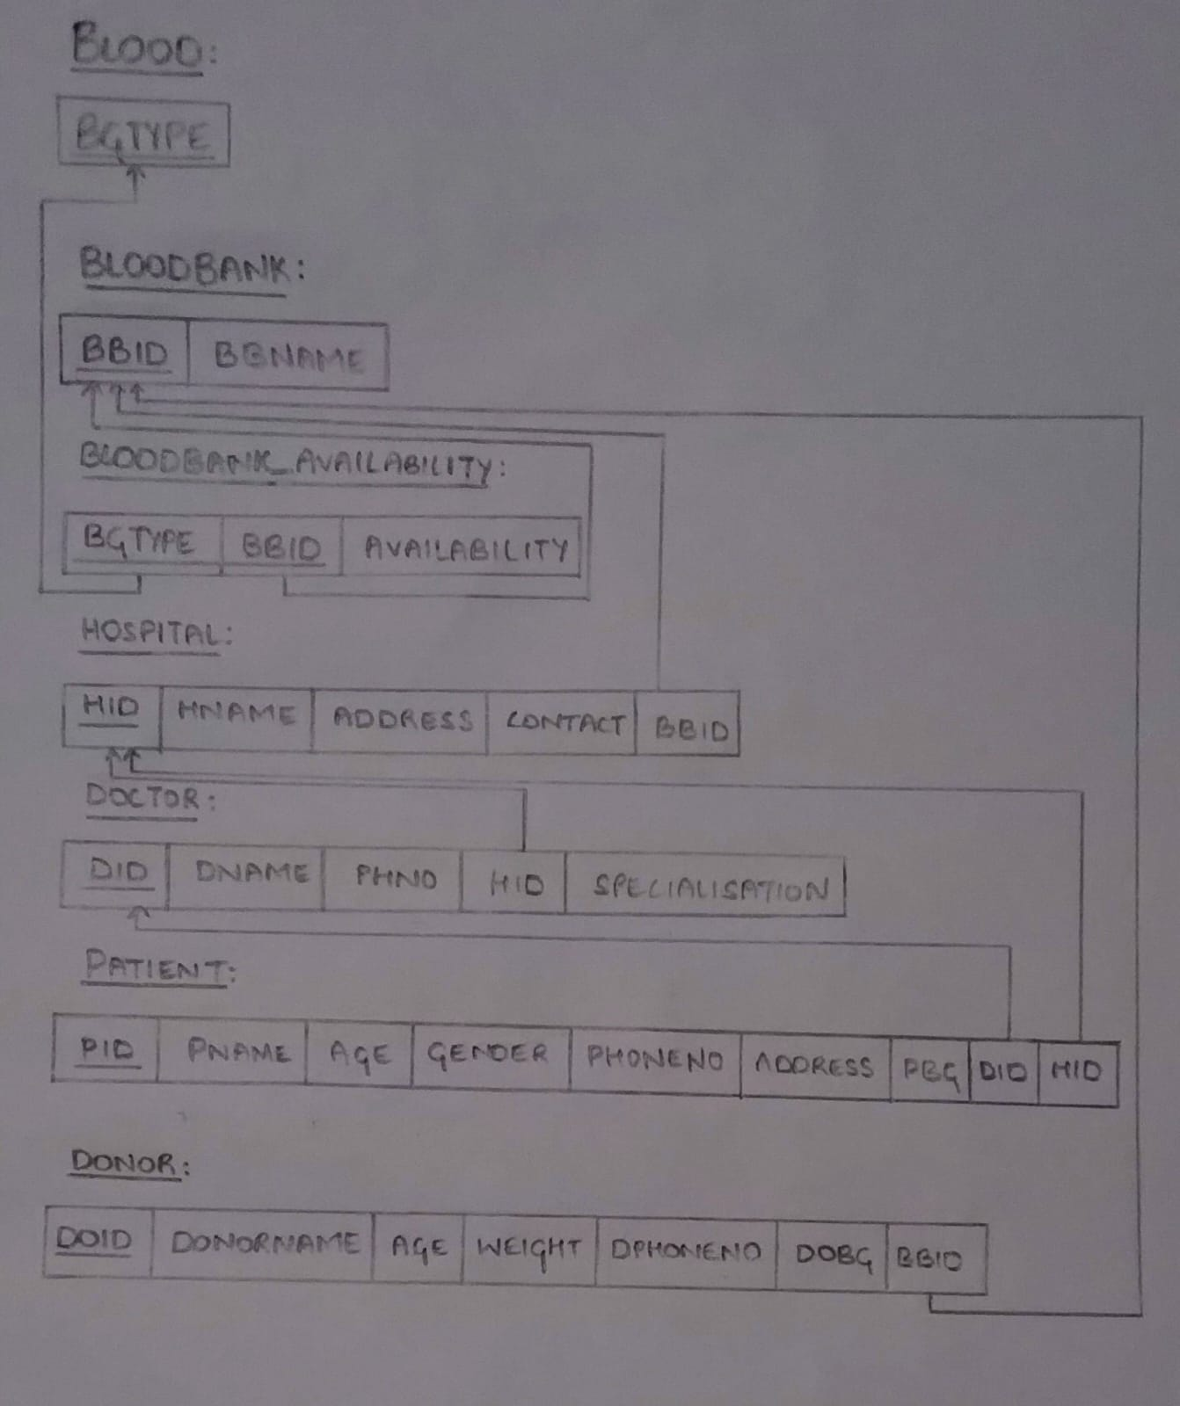

**ENTITY-RELATION DIAGRAM:**

